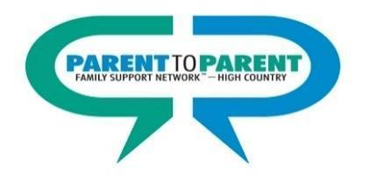

Parent to Parent Family Support Network of the High Country
Serves: Alleghany, Ashe, Avery, Mitchell, Watauga, Wilkes & Yancey

Avery, Mitchell & Yancey
Teresa Emory, Avery/Mitchell/Yancey Outreach Coordinator
Phone: (828) 284-2287
Email: emorytd@appstate.edu

Alleghany, Ashe, Watauga & Wilkes
Office: 2259 Highway 105
Boone, NC 28607
Program Director
Phone: (828) 262-6089
Toll Free Family Line: (866) 812-3122
Email: parent2parent@appstate.edu
Website: https://www.parent2parent.appstate.edu

For the most up to date resources and services, check out our
Resource Directory: https://www.p2presources.com

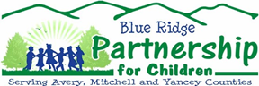
Blue Ridge Partnership for Children Serves: Avery, Mitchell and Yancey
Office: 392 East Main Street Office: 215-B Pineola Street Burnsville, NC 28714 Newland, NC 28657
Phone: (828) 682-0047 Phone: (828) 733-2899 Website: blueridgechildren.org
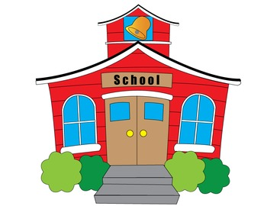

To contact the local Exceptional Children’s Program in your county:

Avery County Schools (Exceptional Children’s Department)
https://www.averyschools.net/children-with-special-needs
Phone: (828) 733-6006

Mitchell County Schools (Exceptional Children’s Department)
http://www.mcsnc.org/departments/exceptional_children
Phone: (828) 766-2220

Yancey County Schools (Exceptional Children’s Department)
https://www.yanceync.net/exceptional-children
Phone: (828) 682-6101 ext. 119

To contact the North Carolina Exceptional Children’s Assistance Center
www.ecac-parentcenter.org Help Line: (800) 962-6817

